*VPCTask1:*

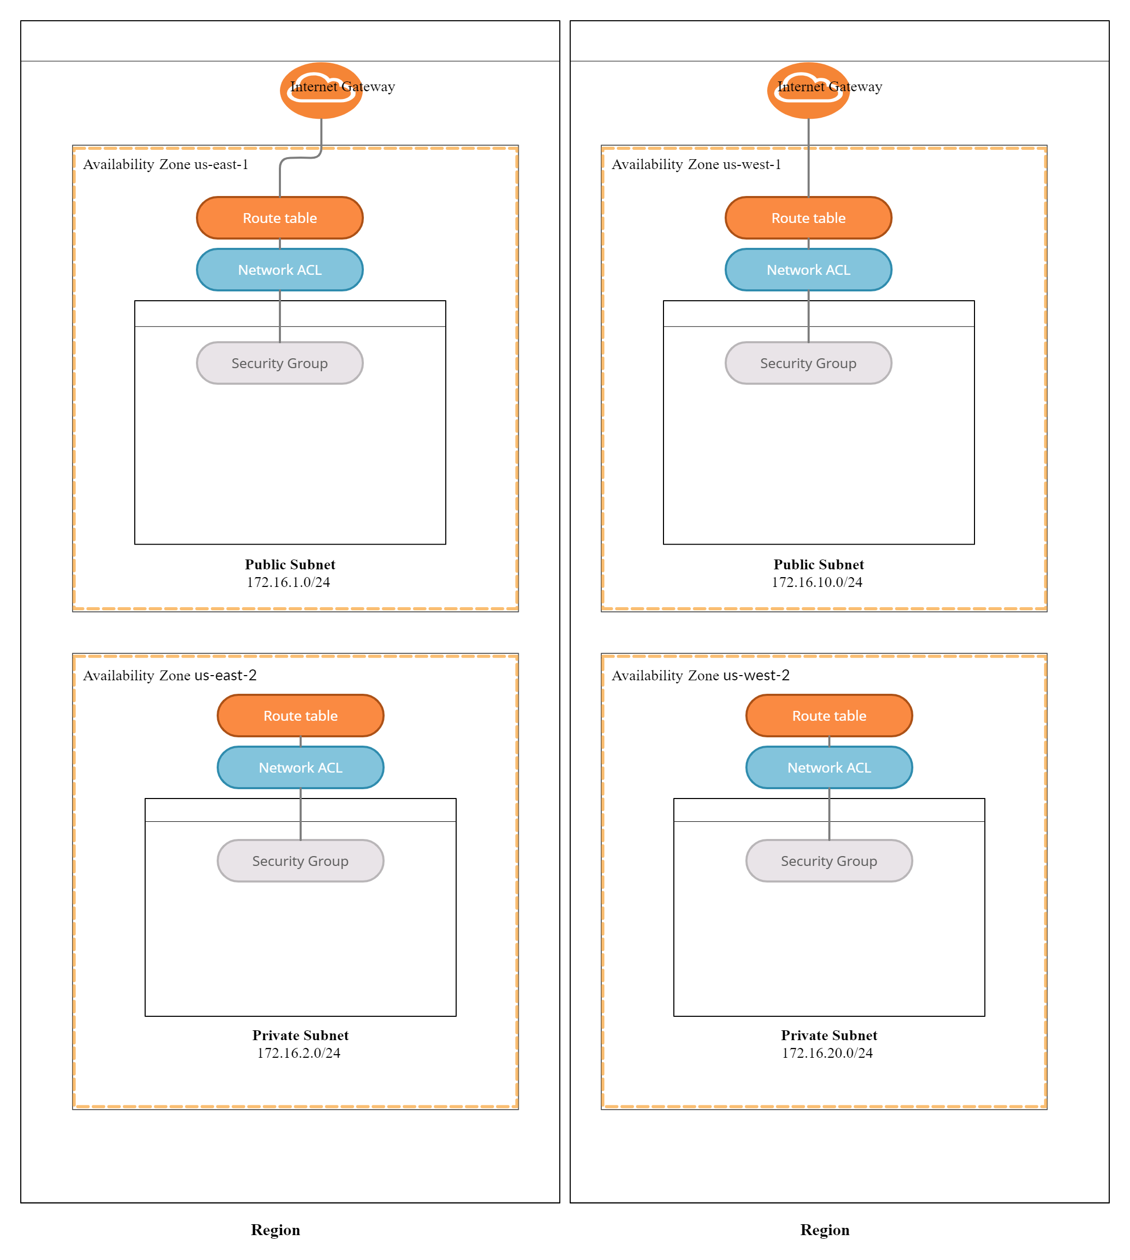

***Create a VPC from scratch (without using the VPC Wizard).***

* *Set the VPC CIDR to 172.16.0.0/16.*
* *Create a public and private subnet in different Availability Zones using the following IP CIDR addresses:*
  + *Public1 subnet in us-east-1: 172.16.1.0/24*
  + *Private1 subnet in us-east-2: 172.16.2.0/24*

***Create Two Network Access Control Lists (NACLs), and Associate Each with the Proper Subnet***

* *Create a public NACL with inbound rules allowing HTTP and SSH traffic, as well as an outbound rule allowing traffic on port range 1024-65535.*
* *Associate the public NACL with the public subnet.*
* *Create a private NACL with an inbound rule allowing SSH traffic with a source of 172.16.1.0/24, as well as an outbound rule allowing traffic on port range 1024-65535.*

***Associate the private NACL with the private subnet.***

* *For the Public_NACL, let the ephemeral port range in the inbound rule with the destination going to 172.16.2.0/24 and a public outbound port 22 going to 172.16.2.0/24.*

***Create an internet gateway, and connect it to the VPC.***

***Create two route tables:***

* *One for the public subnet with an internet gateway route*
* *One for the private subnet without an internet gateway route*
* *For the public route table, create a default route to the internet using the 0.0.0.0/0 CIDR notation.*

*Task 2*

***Create a VPC from scratch (without using the VPC Wizard).***

* *Set the VPC CIDR to 172.16.0.0/16.*
* *Create a public and private subnet in different Availability Zones using the following IP CIDR addresses:*
  + *Public1 subnet in us-west-1: 172.16.10.0/24*
  + *Private1 subnet in us-west-2: 172.16.20.0/24*

***Create Two Network Access Control Lists (NACLs), and Associate Each with the Proper Subnet***

* *Create a public NACL with inbound rules allowing HTTP and SSH traffic, as well as an outbound rule allowing traffic on port range 1024-65535.*
* *Associate the public NACL with the public subnet.*
* *Create a private NACL with an inbound rule allowing SSH traffic with a source of 172.16.10.0/24, as well as an outbound rule allowing traffic on port range 1024-65535.*

***Associate the private NACL with the private subnet.***

* *For the Public_NACL, let the ephemeral port range in the inbound rule with the destination going to 172.16.2.0/24 and a public outbound port 22 going to 172.16.20.0/24.*

***Create an internet gateway, and connect it to the VPC.***

***Create two route tables:***

* *One for the public subnet with an internet gateway route*
* *One for the private subnet without an internet gateway route*
* *For the public route table, create a default route to the internet using the 0.0.0.0/0 CIDR notation.*